Progress Report for a Randomized Trial
Author: Chelsea McCarty Allen (chelsea.allen@hsc.utah.edu)

Motivation
Statisticians provide regular progress reports for randomized trials throughout the enrollment process.
The purpose is to keep the investigator informed about the study, specifically
  - Randomization rates and enrollment projections
  - Demographics of those randomized
  - Baseline and, if appropriate, follow-up measures of outcomes
  - Subjects’ progress in the study

These should be done frequently: weekly, monthly, quarterly, etc. depending on the study. To this end, we want something that requires minimal tinkering and hopefully no copy and paste. Creating this report should be a quick operation.
Ideally, we would download the data, run the code (without needing to make changes) which creates the tables and figures and also outputs the report, and send off the document after only a brief check.
Note: These reports should not give any information about the randomization treatments or give any data stratified by these groups. Any information/outcomes should be summarized over all data without reference to treatments or treatment groups.

Context
There is much more detailed information in the attached “Study and File Information” Word document, but here is a quick overview of this (entirely fabricated) study.
- All data is collected in REDCap and downloaded for R. Files are named to most closely represent this scenario. Data was downloaded on March 10, 2026 and the report is generated on the same day.
- This is a randomized trial with an online prescreening survey, screening, 3 in-person visits, and 2 online check-ins. There are inclusion/exclusion criteria applied at prescreening and at the in-person screening.
- Through power calculations, it is determined that 150 subjects completing the study will be enough to test their hypothesis. Due to known attrition rates, investigators estimate that 180 should be enrolled to enroll enough patients.

Example Report
An entire report (as well as the code to produce it) is provided in the attached files. This document presents most of the tables and figures I would use over the course of a study. At any given time, I would likely only give a subset of the information shown here. In the code, this can be done by just changing the “out.order” vector to only include the plots and tables you want printed.
Given here are the tables and plots with included commentary on how/when they might be useful.

Data was pulled on 2026-03-10.

Figure 1. Enrollment Status
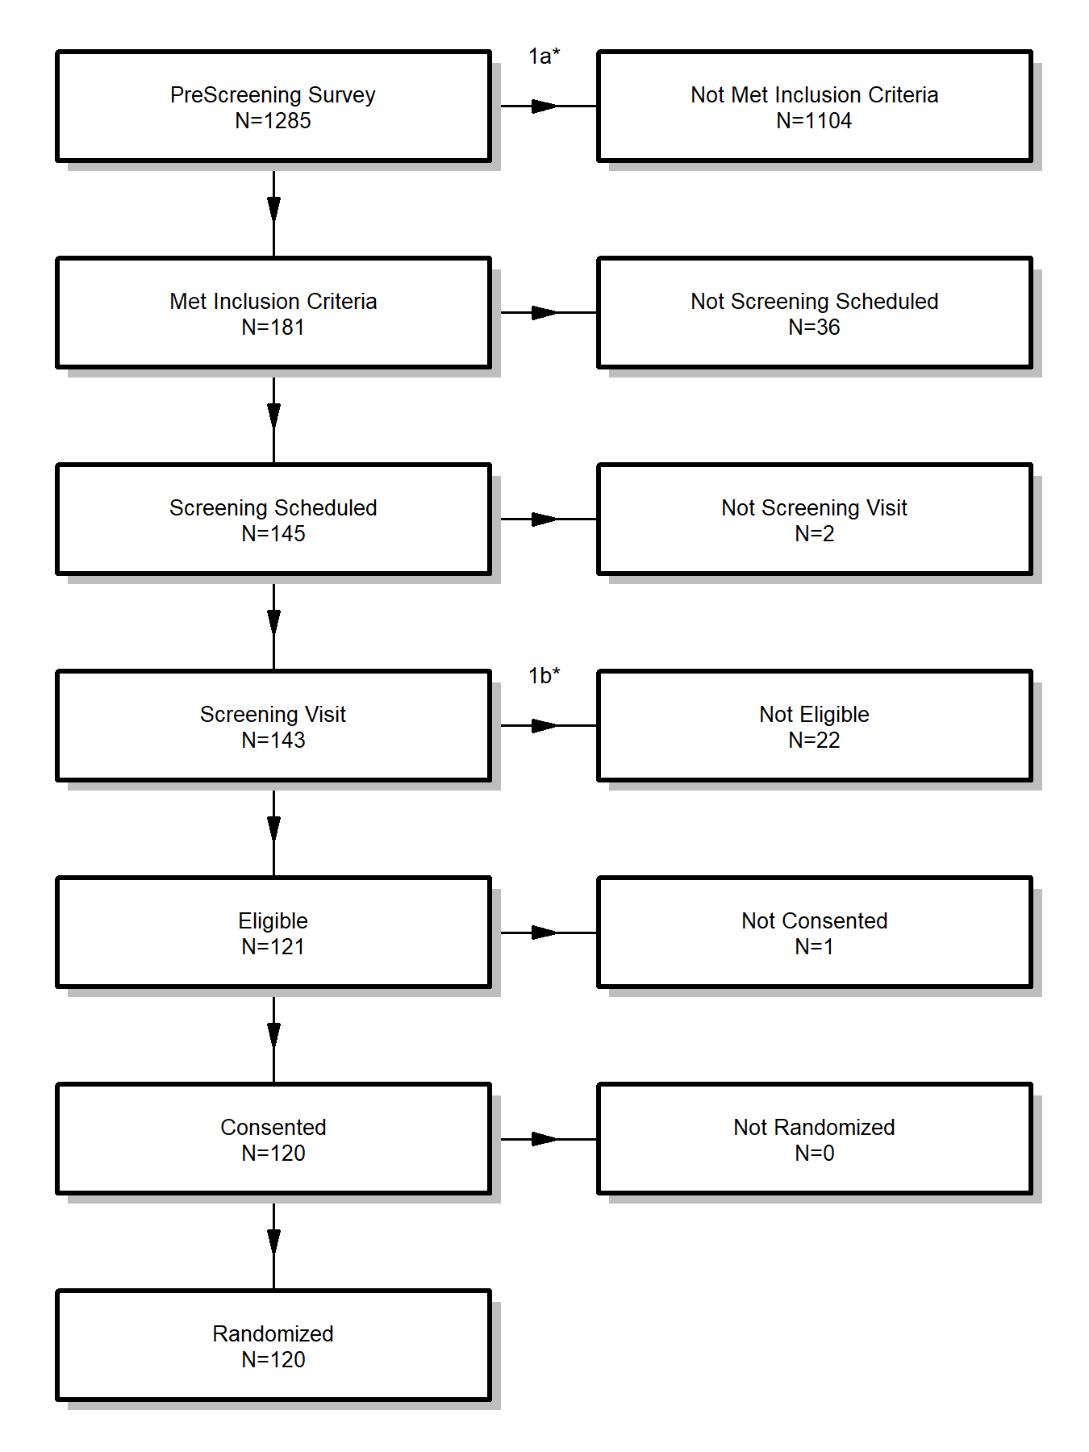
Final enrolled number is 120.
*These exclusions are covered in the indicated table.
This shows the steps to randomization and how many people are progressing through. This is generally helpful any time during randomization.

Table 1a. PreScreening Inclusion Criteria
Inclusion Criteria | Number Failed
Survey 1 > 10 | 706
Survey 2 > 8 | 674
Hypertension/Hypotension | 333
Ability to do study | 151
Some subjects failed to meet multiple inclusion criteria.
Of the 1285 subjects who completed the prescreening survey, 1104 did not meet at least 1 inclusion criteria and 151 met all inclusion criteria and were able to be scheduled for a screening visit.

Table 1b. Exclusions at Screening Visit
Exclusion | Number Excluded
Hypotension in Screening Visit | 1
Hypertension in Screening Visit | 21
Of the 143 subjects who completed the screening visit, 22 were excluded based on one of these criteria and 121 were eligible for randomization.
Tables 1a & 1b. These tables give a count of how many people are being excluded/included based on criteria. Ex. There were 706 subjects that did the prescreening survey, but did not meet the required threshold in Survey 1 to be included (they may also be excluded for other reasons). This is especially useful if the PI is considering changing their strategy of how to recruit people. Otherwise, they might prefer not to see this level of detail.

Table 2. Demographics (Enrolled Only)
N=120 | Type/Level | Summary | # Missing
Sex | Female | 56 (47%) | 0
 | Male | 60 (50%)
 | Other | 1 (<1%)
 | Prefer not to answer | 3 (2%)
Age | [mean (SD)] | 44.7 (8.2) | 0
 | [median (IQR)] | 44 (38.8, 49.2)
 | [range] | (26.0, 68.0)
Race | White/Caucasian | 103 (86%) | 0
 | Asian | 8 (7%)
 | Two or More Races | 3 (2%)
 | Native Hawaiian/Pacific Islander | 2 (2%)
 | Black/African American | 2 (2%)
 | Native American/Alaska Native | 2 (2%)
 | Other | 0 (0%)
 | Prefer not to answer | 0 (0%)
Ethnicity | Not Hispanic or Latino | 95 (79%) | 0
 | Hispanic or Latino | 25 (21%)
Race/Ethnicity | White/Caucasian, Non-Hispanic/Latino | 82 (68%) | 0
 | Hispanic or Latino | 25 (21%)
 | Asian, Non-Hispanic/Latino | 6 (5%)
 | Two or More Races, Non-Hispanic/Latino | 3 (2%)
 | Native Hawaiian/Pacific Islander, Non-Hispanic/Latino | 1 (<1%)
 | Black/African American, Non-Hispanic/Latino | 2 (2%)
 | Native American/Alaska Native, Non-Hispanic/Latino | 1 (<1%)
 | Other | 0 (0%)
 | Prefer Not to Answer | 0 (0%)

Table 2: Any randomization strata should also be included here. If there are multiple sites, consider stratifying the table by site.

Table 3. Physical Measures (Enrolled Only)
Variable | Baseline: N=120 | Week 8: N=105 | Month 6: N=78 | #Missing
SBP
[mean (SD)] | 112.1 (8.7) | 110.9 (10.6) | 105.4 (13.6) | 0 / 0 / 0
[median (IQR)] | 112 (106.8, 118) | 111 (103, 119) | 106.5 (93.2, 114.8)
[range] | (87.0, 129.0) | (87.0, 137.0) | (69.0, 132.0)
DBP
[mean (SD)] | 69.7 (6.2) | 68.2 (6.5) | 64.9 (7.5) | 0 / 0 / 0
[median (IQR)] | 71 (66, 74) | 69 (64, 72) | 64 (60.2, 70)
[range] | (49.0, 79.0) | (46.0, 83.0) | (41.0, 84.0)
BMI
[mean (SD)] | 31.0 (5.3) | 31.4 (5.3) | 31.1 (5.6) | 0 / 0 / 0
[median (IQR)] | 30.8 (28, 34.6) | 30.9 (28.2, 35) | 31 (28, 35)
[range] | (17.2, 43.5) | (17.4, 44.4) | (17.0, 44.0)

Table 4. Survey Scores (Enrolled Only)
Variable | Baseline: N=120 | Week 4: N=109 | Week 8: N=105 | Month 3: N=83 | Month 6: N=78 | #Missing
Score 1
[mean (SD)] | 20.3 (7.1) | 20.3 (8.0) | 20.6 (7.4) | 23.3 (11.5) | 22.6 (10.4) | 0 / 0 / 0 / 0 / 0
[median (IQR)] | 20 (15, 25) | 20 (15, 27) | 20 (16, 25) | 23 (16.5, 30) | 23 (15.2, 29)
[range] | (5.0, 37.0) | (1.0, 42.0) | (4.0, 39.0) | (0, 59.0) | (0, 50.0)
Score 2
[mean (SD)] | 6.9 (3.0) | 6.9 (3.1) | 7.3 (3.2) | 7.8 (3.9) | 7.6 (3.7) | 0 / 0 / 0 / 0 / 0
[median (IQR)] | 7 (5, 9) | 6 (5, 9) | 7 (5, 9) | 7 (5, 11) | 7 (5, 10)
[range] | (1.0, 14.0) | (1.0, 14.0) | (1.0, 14.0) | (1.0, 14.0) | (1.0, 14.0)
Self-Report 1
[mean (SD)] | 51.4 (14.8) | 48.2 (16.3) | 46.3 (15.6) | 44.5 (18.6) | 42.0 (18.4) | 0 / 0 / 0 / 0 / 0
[median (IQR)] | 52 (41.5, 62) | 50 (37, 59) | 48 (37, 56) | 46 (34, 57) | 43 (29, 54.8)
[range] | (17.0, 85.0) | (8.0, 90.0) | (10.0, 85.0) | (0, 80.0) | (0, 87.0)
Self-Report 2
[mean (SD)] | 51.6 (16.2) | 56.2 (16.7) | 62.2 (16.0) | 66.7 (17.5) | 75.8 (16.3) | 0 / 0 / 0 / 0 / 0
[median (IQR)] | 50.5 (39, 63) | 56 (45, 68) | 60 (50, 73) | 66 (55.5, 78) | 76.5 (64, 89.5)
[range] | (14.0, 88.0) | (19.0, 95.0) | (24.0, 100.0) | (20.0, 100.0) | (40.0, 100.0)

Tables 3 & 4 give ongoing reports of important data. This allows us to catch issues (such as impossibly low or high values) early on rather than saving all data and quality checks for the end. This also lets us track if key variables are frequently going missing.

Figure 2. Study Progress
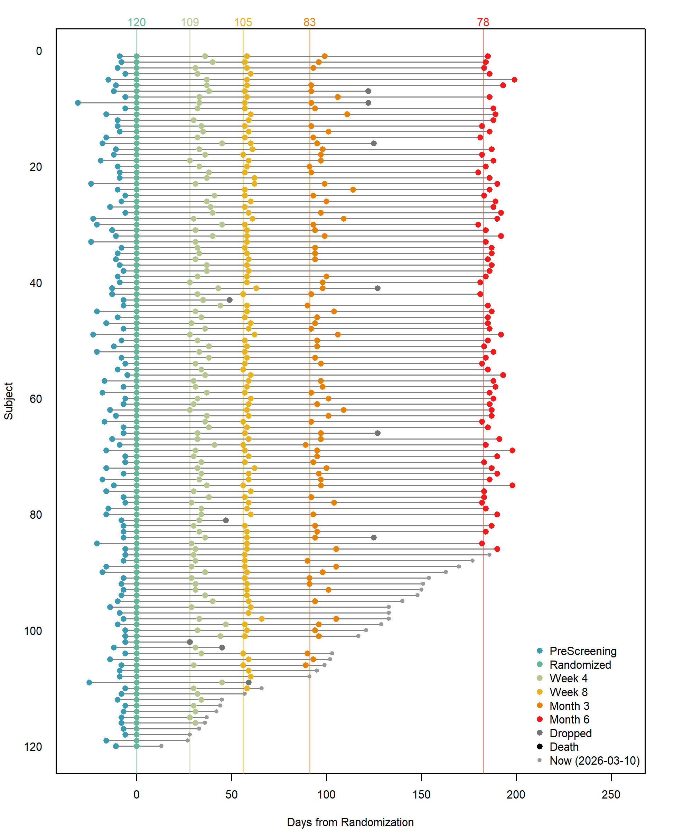
Days are from randomization time (negative are before).
Figure 2 shows the progress of each subject in the study. Each horizontal line represents as single subject and events (usually visits or online check-ins) are marked relative to when the subject was randomized. Horizontal lines give when certain events should occur relative to baseline and numbers at the top give how many subjects have completed the event. For subjects that were dropped/removed from the study, when that occurred is shown – here the possibilities are “Dropped” and “Death”. For those who have not left the study (by completion or leaving), “Now” – the date data was pulled – is given. For example, the last subject has not completed anything beyond their randomization/baseline visit, but the “Now” indicator shows they have not been in the study long enough that we would expect any other events to have been reached.

Figure 3. Summary Study Progress (In-person Visits only)
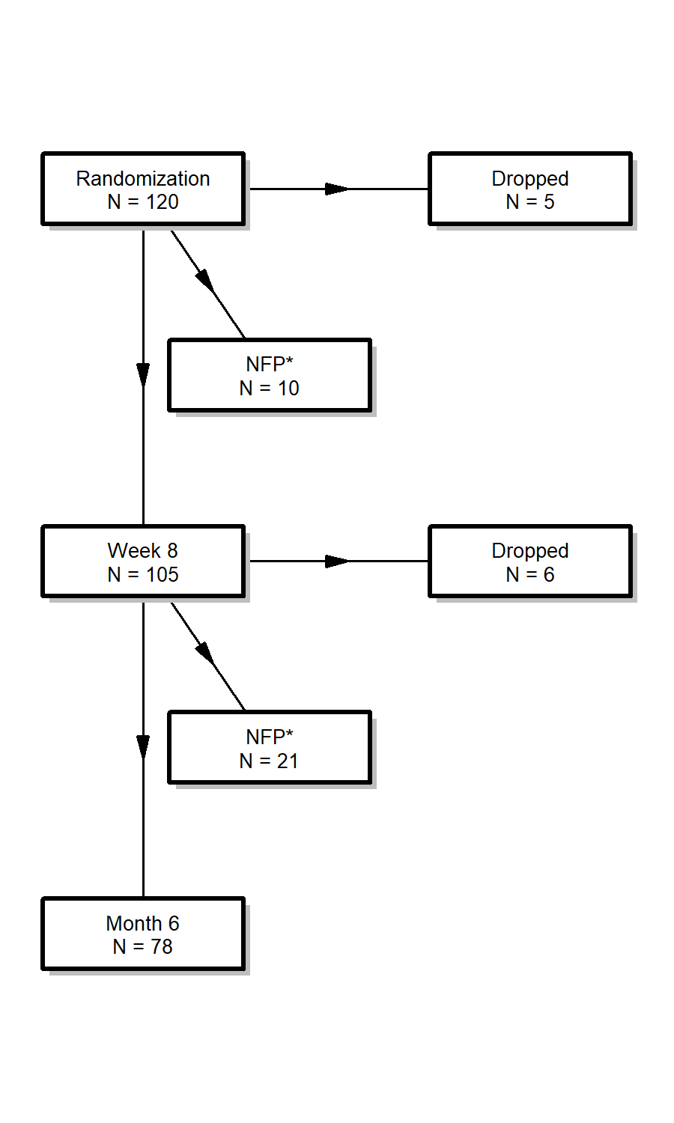
*NFP = No Further Progress: participants that haven't done the next visit but have not dropped.
Drop out rate percentages below are calculated without considering the “NFP” group. It is the percentage of those who dropped out of those who either dropped out or continued.
Drop Rate by Study Status:
- After Randomization and before the next visit there was a 5% drop out rate.
- 5 dropped out of 110 participants who either dropped or continued.
- After Week 8 and before the next visit there was a 7% drop out rate.
- 6 dropped out of 84 participants who either dropped or continued.
Based on the observed attrition rates, we would project that 106 of the subjects enrolled will complete the study (this includes the 78 who have already completed).
To reach the goal of 150 completed subjects, we estimate we need to enroll 50 more subjects, making 170 enrolled in total.
Figure 3 gives a data-driven view of attrition rates. Often an attrition rate is estimated based on past studies in the research area, but might not be correct for the population being studied. In the comments, it also gives a calculated value for how many would need to be enrolled to reach the desired number of those who complete the study based on the observed attrition rates. This is especially important if the attrition rate is actually higher than expected. This may mean there should be a push to enroll so that the number of subjects completing the study will still reach their desired number. This figure is generally not very useful until enough subjects have completed the study to give fairly steady estimates.

Figure 4. Subject Screening Numbers
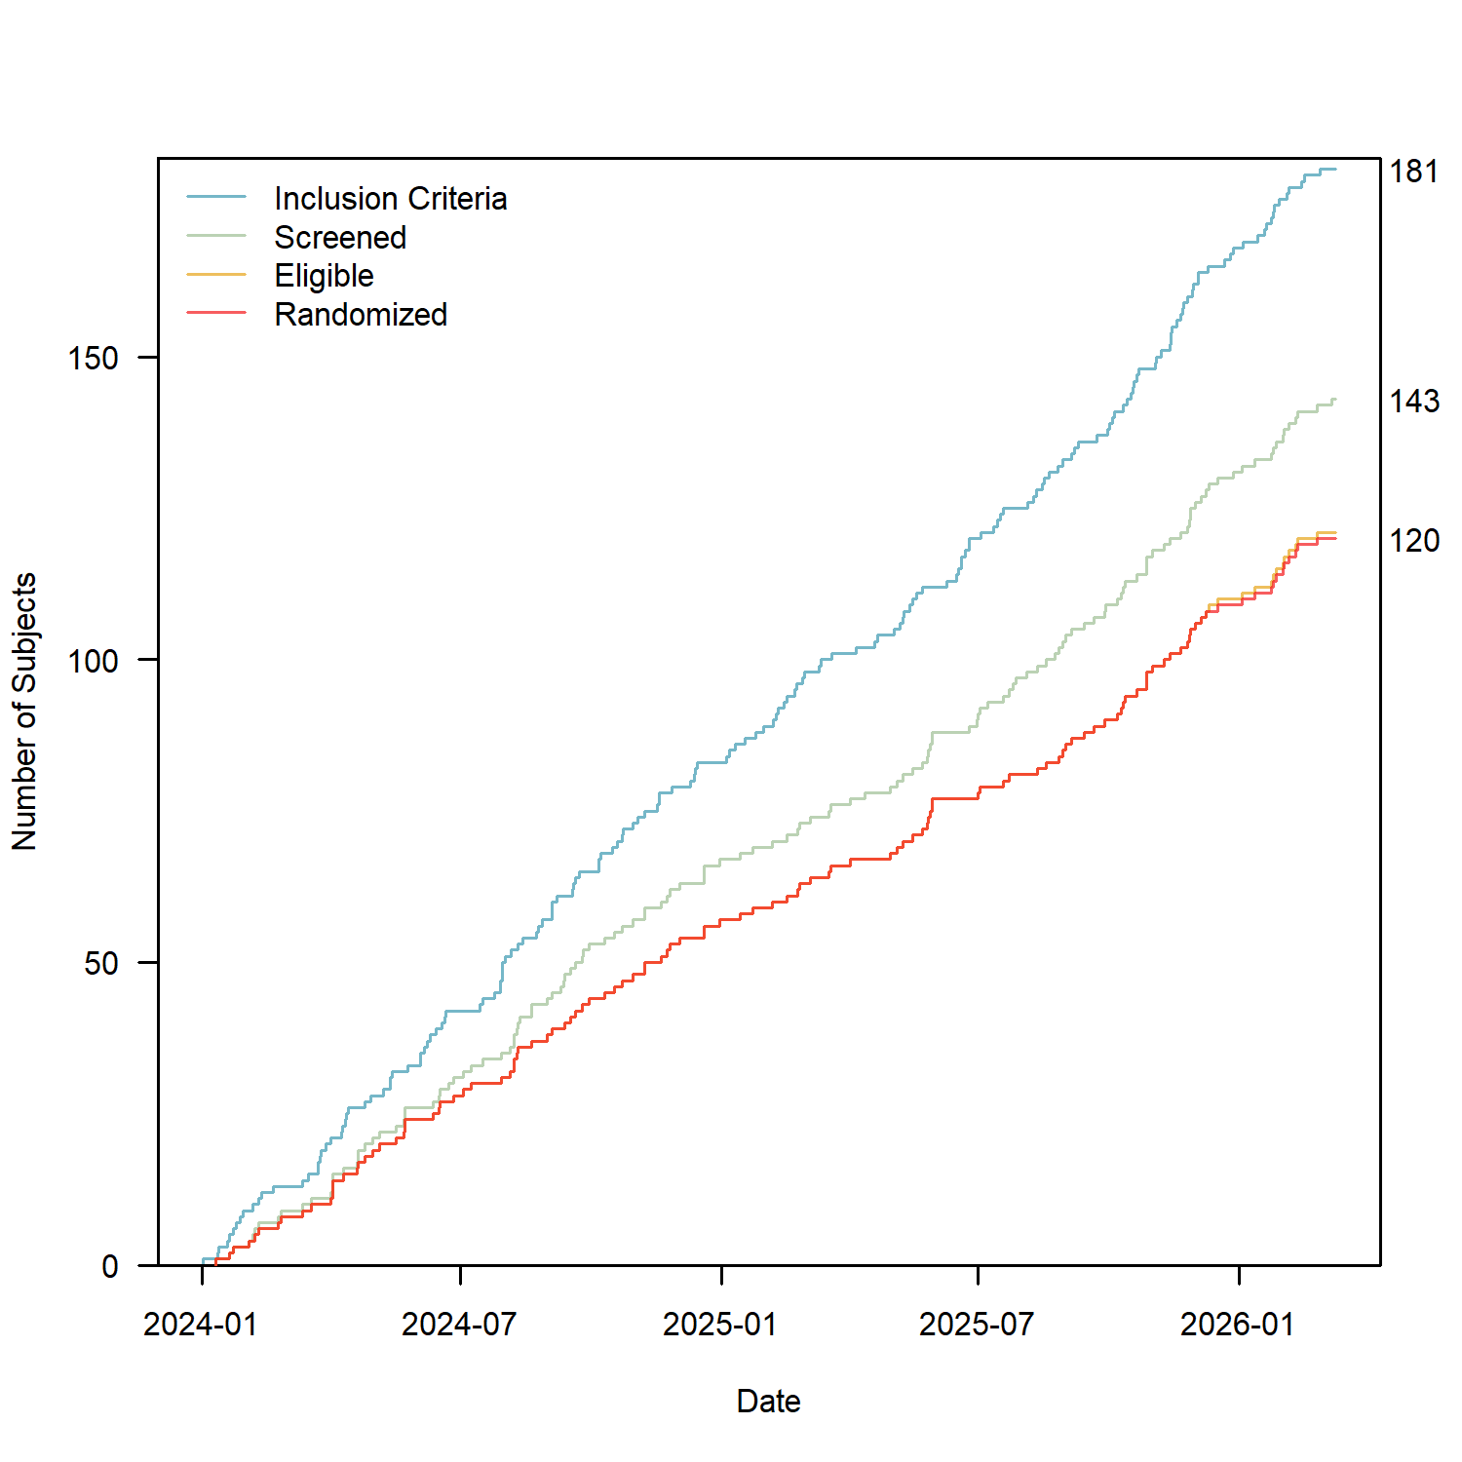

Figure 4 gives another view of how many people are progressing through the screening process, but specifically over time. Important dates – such as a change in protocol, change in inclusion/exclusion criteria, major event such as the COVID pandemic, etc. – could be marked on this graph as well to see changes in enrollment rates.

Figure 5. Enrollment Numbers
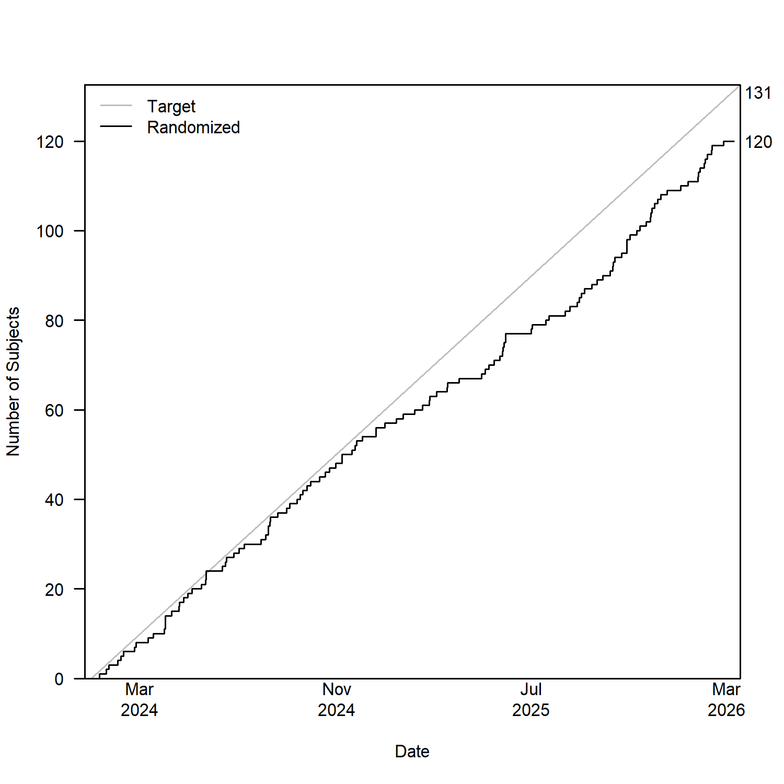
First day is taken as 2024-01-01. Our target is to enroll 5 per month.
Our overall enrollment rate is 4.6 subjects per month and the rate for the last 3 months is 4.3 subjects per month.
Figure 5 shows the enrollment rate compared to the target enrollment rate. In this example, you can see that enrollment has fallen behind target. The averages here are not weighted, but straightforward means based on the complete months that have passed.

Figure 6. Projected Enrollment
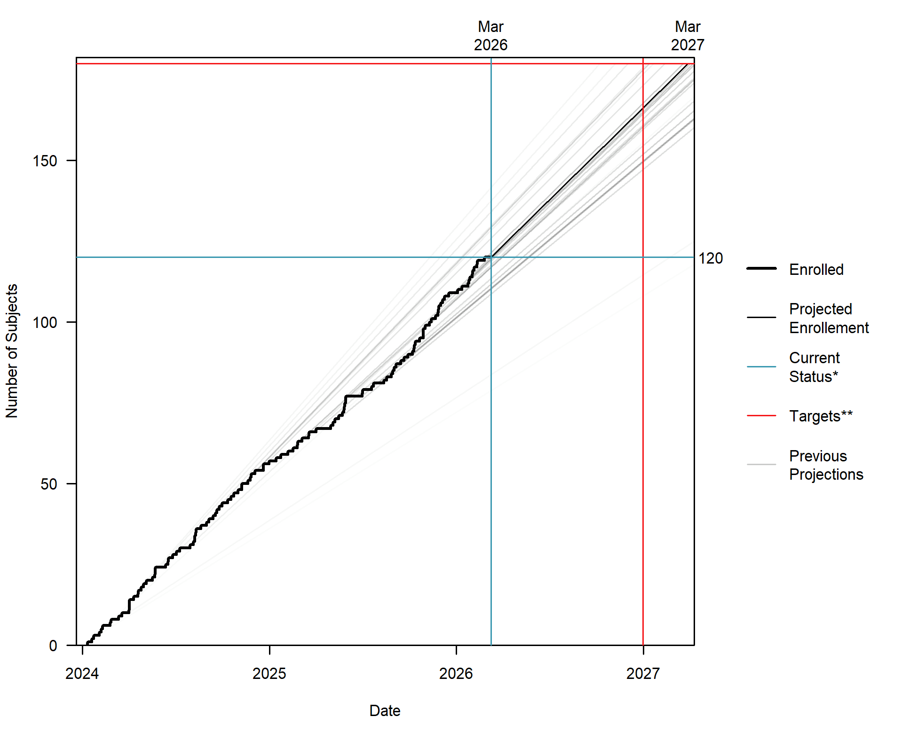
*Current Status is the current number enrolled, 120, and the date data was pulled, 2026-03-10.
**Targets is the targeted enrollment, 180, and the targeted end date, 2026-12-31.
At the current estimated pace of 4.74 enrollments per month we are projected to reach 180 by 2027-03-29, or projected to reach 166 by the end date, 2026-12-31. This estimated pace was produced with a weighted average of previous monthly enrollments and is recalculated on the 1st of each month.
In order to reach the targeted 180 subjects (60 remaining) by 2026-12-31 we need to enroll 6.17 subjects per month.
Enrollment for the past 3 months
Dec 2025: 4
Jan 2026: 5
Feb 2026: 6
Figure 6 (like Figure 5) shows the enrollment over time. Unlike Figure 5, Figure 6 projects the enrollment through the end of the enrollment period, based on current data. Red lines represent the target amount to enroll and the scheduled end of enrollment. Blue lines represent the current enrollment and current date (when the data was pulled). Within the comments a weighted mean of enrollment per month is calculated, with highest weight being given to the most recently completed months and using that we project how many would be enrolled by the end date or how long it would take to reach the target number of enrollments. It also gives the enrollment rate necessary to reach the targeted amount by the end date. This graph can be used as soon as enrollment begins but will likely give very unsteady estimates until at least 6 months in, especially if there is a delay from the start of enrollment to the first subject randomized.

Figure 7. State of the Study
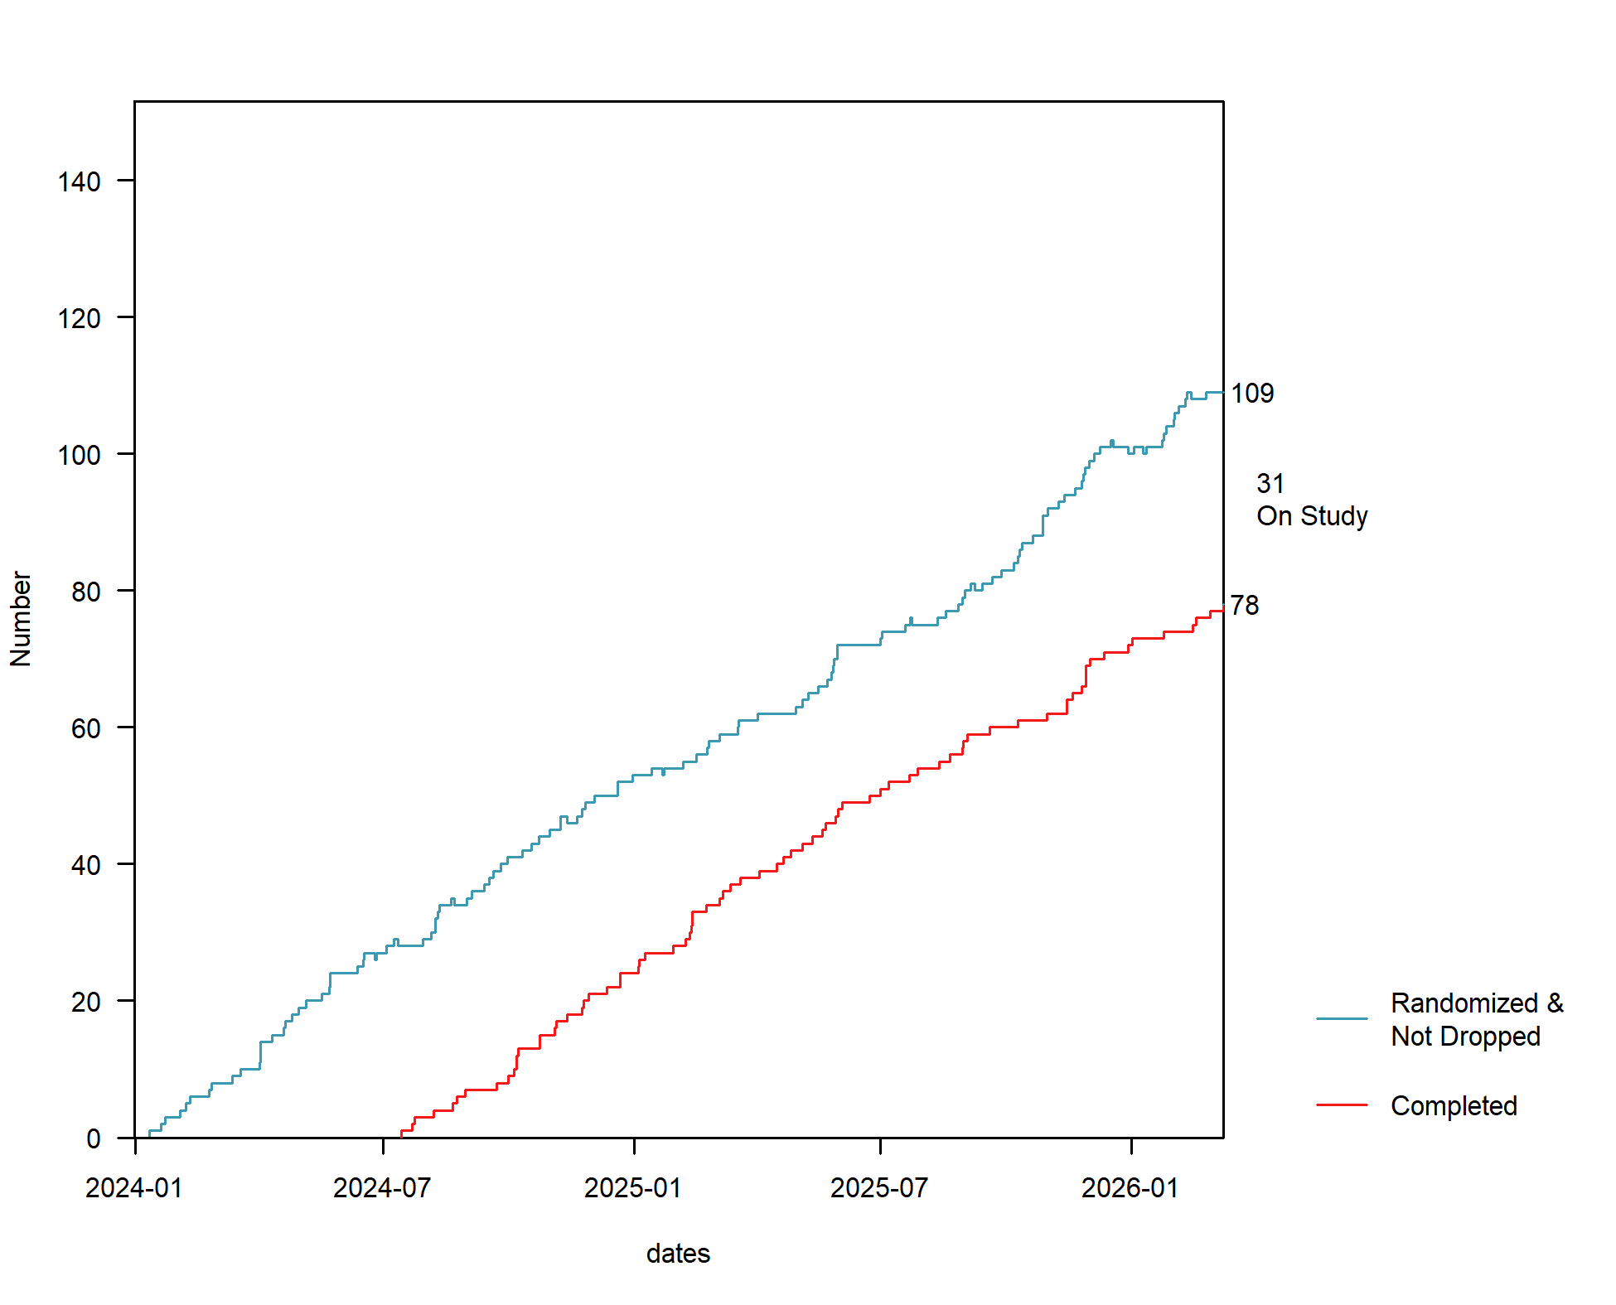
There are 109 subjects randomized that have not dropped. This figure includes the 78 subjects that have completed the study and the 31 subjects that are currently still in the study (i.e. have neither dropped nor completed).
Based on the observed attrition rates, we would project that 28 of the 31 subjects that are on study will complete it, making a total of 106 completed subjects.
Unlike the figures that focus on how many are enrolled, Figure 7 focuses on how many have completed the study. So the number randomized over time are tracked, but when someone drops, they are removed. The number completed are also tracked as well and the number currently on study (enrolled, not dropped, and not completed) is given. This is generally not needed until the study is nearing completion and can be used even after enrollment ends to track whether it looks like we will meet our target number of subjects completing the study.

Supplement Files
Additional files are given in order to run this report (in R) on your own. The data is assumed to have been downloaded from REDCap and the code focuses heavily on reproducibility. Included in the files are
- "Study and File Information" document that goes into greater detail on the invented study and goes deep into detail if you want to use my code and modify it to your needs
- Analysis folder
  - Analysis R project file
  - Progress Report Code (R file to run to generate the progress report)
  - Clean Data Code & Functions R files which are sourced in the Progress Report Code file
  - Progress Reports folder where completed report files will output
- Data folder
  - R and csv files formatted like a REDCap data download

